Set 21: Energy Consumption Analysis
Dataset: Energy_Consumption_Data.csv
energy <- data.frame(
Sector = c("Residential","Commercial","Industrial","Residential","Commercial","Industrial"),
Region = c("North","South","West","East","North","South"),
Month = c("Jan","Jan","Feb","Feb","Mar","Mar"),
Temperature = c(15,24,20,18,28,30),
Units_Consumed = c(320,540,880,350,610,920),
Cost = c(2100,3600,5900,2300,4100,6200),
Renewable_Usage = c(22,18,12,25,20,15),
Peak_Hours = c(4,6,8,5,7,9)
)
a) Histogram and Density Plot for Units_Consumed
R code:
par(mfrow = c(1,2))
hist(energy$Units_Consumed,
main = "Histogram of Units Consumed",
xlab = "Units Consumed (kWh)",
col = "lightblue", border = "black")
plot(density(energy$Units_Consumed),
main = "Density Plot of Units Consumed",
xlab = "Units Consumed (kWh)",
col = "darkblue", lwd = 2)
polygon(density(energy$Units_Consumed),
col = rgb(0,0,1,0.2), border = "darkblue")
output:
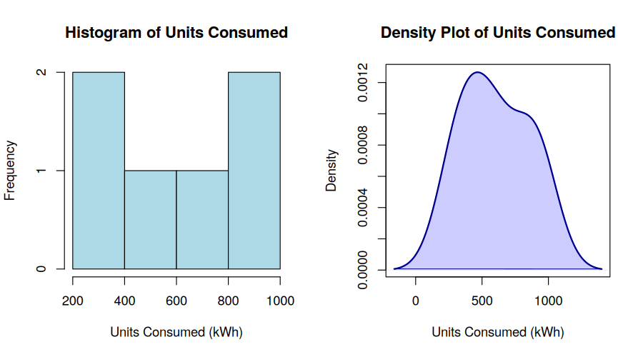
Interpretation: Units_Consumed shows a bimodal spread — a cluster of lower residential/commercial consumption (300-600 kWh) and a separate cluster of high industrial consumption (850-950 kWh). The density plot confirms two overlapping peaks rather than a single normal distribution.
b) Scatter Plot: Temperature vs Units_Consumed (Bubble = Peak_Hours)
R code:
plot(energy$Temperature, energy$Units_Consumed,
cex = energy$Peak_Hours / 2,
pch = 21,
bg = rgb(1,0,0,0.4),
col = "darkred",
xlab = "Temperature (deg C)",
ylab = "Units Consumed (kWh)",
main = "Temperature vs Units Consumed (Bubble = Peak Hours)")
output:
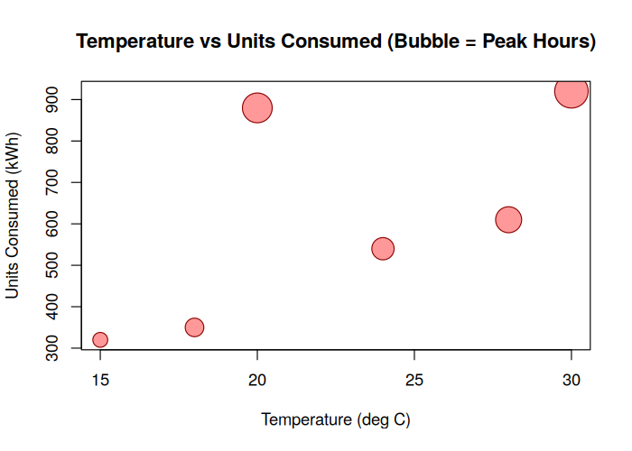
c) Average Renewable_Usage by Sector
R code:
avg_renew <- aggregate(Renewable_Usage ~ Sector, data = energy, FUN = mean)
barplot(avg_renew$Renewable_Usage,
names.arg = avg_renew$Sector,
col = c("seagreen","goldenrod","tomato"),
xlab = "Sector", ylab = "Average Renewable Usage (%)",
main = "Average Renewable Energy Usage by Sector")
output:
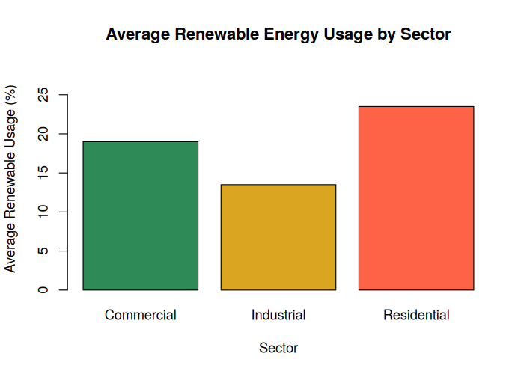
d) Tableau: Monthly Trend Line Chart, Sector-Region Heatmap and Interactive Dashboard
R code:
library(shiny)
ui <- fluidPage(
titlePanel("Energy Consumption Dashboard"),
sidebarLayout(
sidebarPanel(
selectInput("month", "Month:", choices = c("All", "Jan","Feb","Mar")),
selectInput("sector", "Sector:", choices = c("All", unique(energy$Sector)))
),
mainPanel(
plotOutput("trendPlot"),
plotOutput("heatPlot")
)
)
)
server <- function(input, output) {
output$trendPlot <- renderPlot({
monthly <- aggregate(Units_Consumed ~ Month, data = energy, FUN = sum)
monthly$Month <- factor(monthly$Month, levels = c("Jan","Feb","Mar"))
monthly <- monthly[order(monthly$Month), ]
plot(1:3, monthly$Units_Consumed, type = "o", col = "blue", lwd = 2,
pch = 16, xaxt = "n", xlab = "Month", ylab = "Total Units (kWh)",
main = "Monthly Energy Usage Trend")
axis(1, at = 1:3, labels = monthly$Month)
})
output$heatPlot <- renderPlot({
heat_data <- xtabs(Units_Consumed ~ Sector + Region, data = energy)
image(1:ncol(heat_data), 1:nrow(heat_data), t(heat_data),
col = heat.colors(20, rev = TRUE), axes = FALSE,
xlab = "Region", main = "Sector vs Region Heatmap")
axis(1, at = 1:ncol(heat_data), labels = colnames(heat_data))
axis(2, at = 1:nrow(heat_data), labels = rownames(heat_data), las = 2)
})
}
shinyApp(ui = ui, server = server)
output:
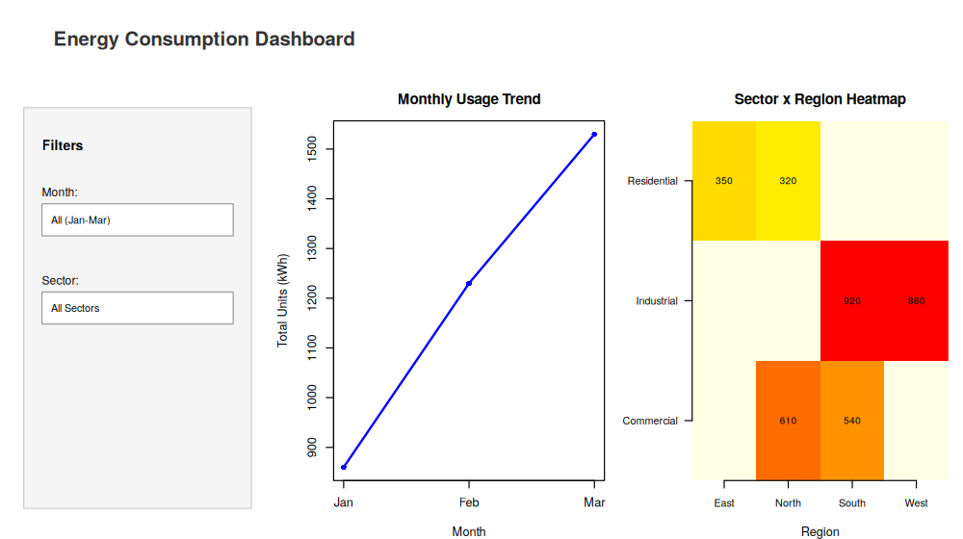

Set 22: Time Series Analysis
Dataset: Monthly Sales Data
sales <- data.frame(
Month = c("January","February","March","April","May"),
Sales = c(15000,18000,22000,20000,23000),
Advertising = c(2000,2500,3000,2800,3500)
)
a) Time Series Line Chart for Monthly Sales
R code:
ts_sales <- ts(sales$Sales, start = 1, frequency = 1)
plot(ts_sales, type = "o", col = "blue", lwd = 2, pch = 16,
xaxt = "n", xlab = "Month", ylab = "Sales ($)",
main = "Monthly Sales Trend (Time Series)")
axis(1, at = 1:5, labels = sales$Month)
output:
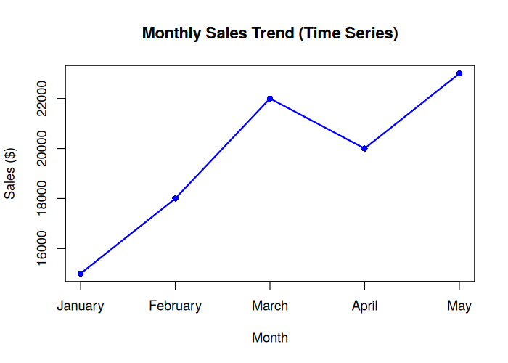
b) Scatter Plot: Advertising Budget vs Monthly Sales
R code:
plot(sales$Advertising, sales$Sales,
pch = 19, col = "red",
xlab = "Advertising Budget ($)", ylab = "Monthly Sales ($)",
main = "Advertising Budget vs Monthly Sales")
abline(lm(Sales ~ Advertising, data = sales), col = "blue", lwd = 2)
output:
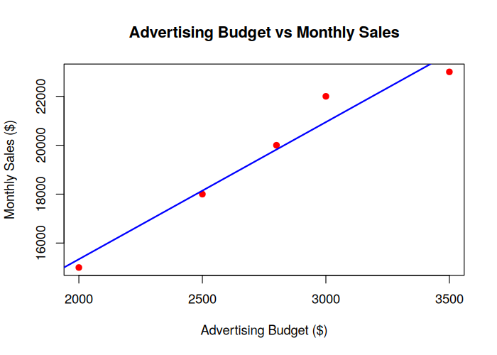
Insight: Sales rise steadily as advertising spend increases, and the regression line shows a strong positive linear relationship between advertising budget and monthly sales.
c) Tableau Dashboard: Sales Trend Line Chart + Product Distribution Pie Chart
R code:
library(shiny)
total_sales <- sum(sales$Sales)
products <- data.frame(Product = c("Product A","Product B","Product C"),
Share = c(0.40, 0.35, 0.25))
products$Sales <- round(total_sales * products$Share)
ui <- fluidPage(
titlePanel("Monthly Sales Dashboard"),
sidebarLayout(
sidebarPanel(selectInput("range", "Month Range:", choices = c("Jan - May"))),
mainPanel(plotOutput("trendPlot"), plotOutput("pieChart"))
)
)
server <- function(input, output) {
output$trendPlot <- renderPlot({
plot(1:5, sales$Sales, type = "o", col = "blue", lwd = 2, pch = 16,
xaxt = "n", xlab = "Month", ylab = "Sales ($)", main = "Sales Trend")
axis(1, at = 1:5, labels = substr(sales$Month,1,3))
})
output$pieChart <- renderPlot({
pie(products$Sales,
labels = paste0(products$Product, "\n", round(products$Share*100), "%"),
col = c("skyblue","orange","seagreen"),
main = "Sales Distribution by Product")
})
}
shinyApp(ui = ui, server = server)
output:
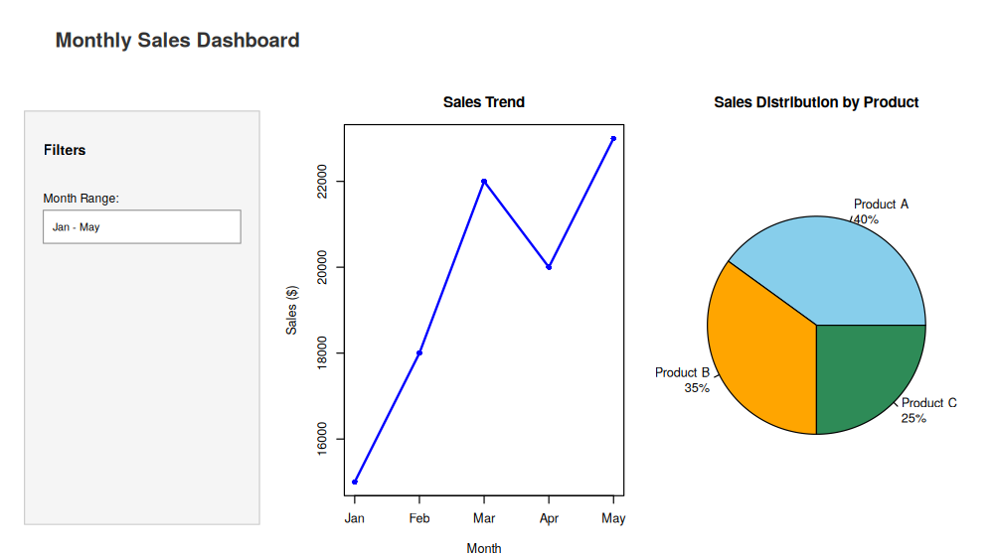
d) Autocorrelation Plot to Identify Seasonality
R code:
acf(sales$Sales, main = "Autocorrelation of Monthly Sales")
output:
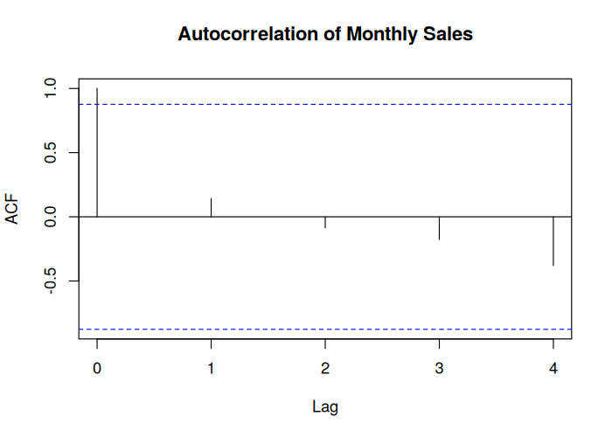

Set 23: Employee Performance Analysis
Dataset: Employee Performance
employee <- data.frame(
EmployeeID = c(1,2,3,4,5),
Department = c("Sales","HR","Marketing","Sales","HR"),
YearsService = c(5,3,7,4,2),
Performance = c(85,92,78,90,76)
)
a) Bar Chart: Distribution of Employees Across Departments
R code:
dept_count <- table(employee$Department)
barplot(dept_count,
col = c("skyblue","orange","green"),
xlab = "Department", ylab = "Number of Employees",
main = "Employees by Department")
output:
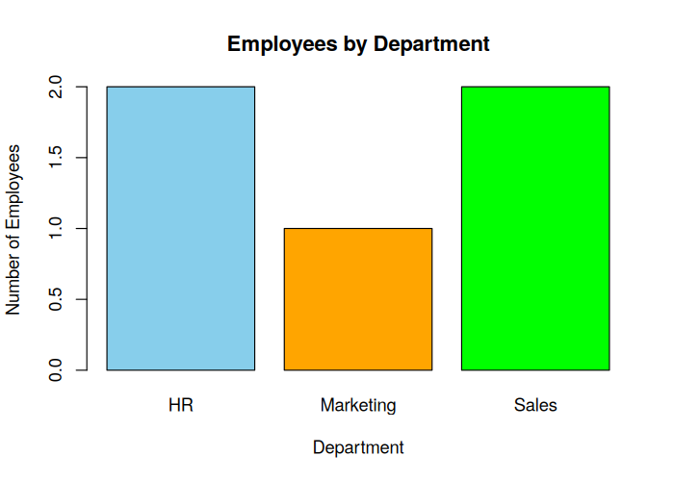
b) Line Chart: Employee Performance Trend
R code:
plot(employee$EmployeeID, employee$Performance, type = "o",
col = "blue", lwd = 2, pch = 16,
xlab = "Employee ID", ylab = "Performance Score",
main = "Employee Performance Trend")
output:
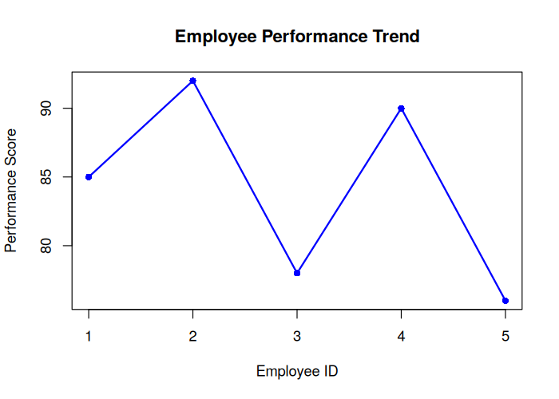
c) Tableau Dashboard: Department Distribution + Years of Service vs Performance
R code:
library(shiny)
ui <- fluidPage(
titlePanel("Employee Performance Dashboard"),
sidebarLayout(
sidebarPanel(selectInput("dept", "Department:", choices = c("All", unique(employee$Department)))),
mainPanel(plotOutput("deptPlot"), plotOutput("scatterPlot"))
)
)
server <- function(input, output) {
output$deptPlot <- renderPlot({
barplot(table(employee$Department), col = c("skyblue","orange","green"),
xlab = "Department", ylab = "Number of Employees",
main = "Employees by Department")
})
output$scatterPlot <- renderPlot({
plot(employee$YearsService, employee$Performance, pch = 19, col = "red",
xlab = "Years of Service", ylab = "Performance Score",
main = "Years of Service vs Performance")
abline(lm(Performance ~ YearsService, data = employee), col = "blue", lwd = 2)
})
}
shinyApp(ui = ui, server = server)
output:
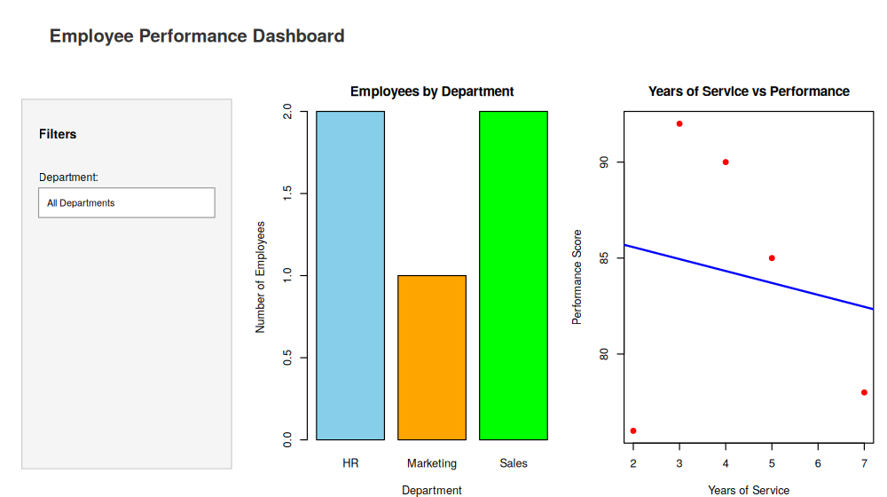
d) Table: Performance Data for Each Employee
R code:
print(employee)
# Rendered as a formatted table below
output:
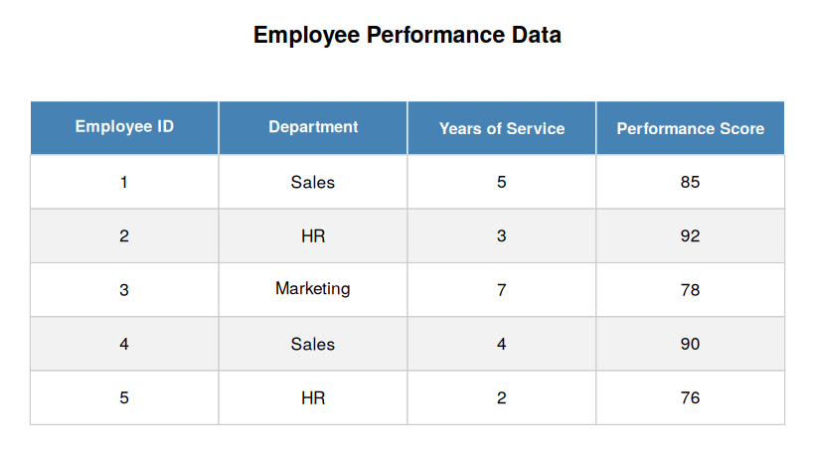

Set 24: Product Inventory Management
Dataset: Product Inventory
inventory <- data.frame(
ProductID = c(1,2,3,4,5),
ProductName = c("Product A","Product B","Product C","Product D","Product E"),
Quantity = c(250,175,300,200,220),
Category = c("Electronics","Electronics","Furniture","Furniture","Furniture"),
Price = c(100,150,80,120,90)
)
a) Bar Chart: Quantity of Each Product in Inventory
R code:
barplot(inventory$Quantity,
names.arg = inventory$ProductName,
col = "skyblue",
xlab = "Product Name", ylab = "Quantity Available",
main = "Product Inventory")
output:
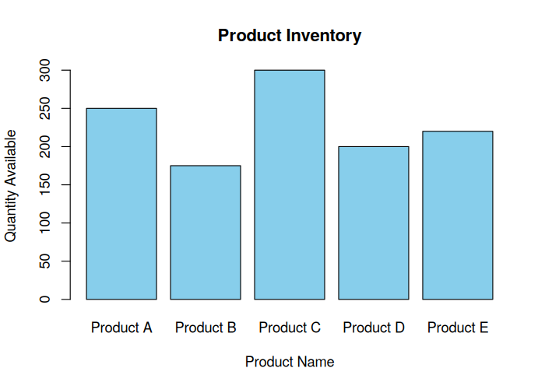
b) Stacked Bar Chart: Quantity by Product Category
R code:
table_data <- xtabs(Quantity ~ Category + ProductName, data = inventory)
barplot(table_data, beside = FALSE,
col = rainbow(ncol(table_data)),
main = "Product Quantity by Category",
xlab = "Category", ylab = "Quantity")
legend("topright", legend = colnames(table_data),
fill = rainbow(ncol(table_data)), title = "Products")
output:
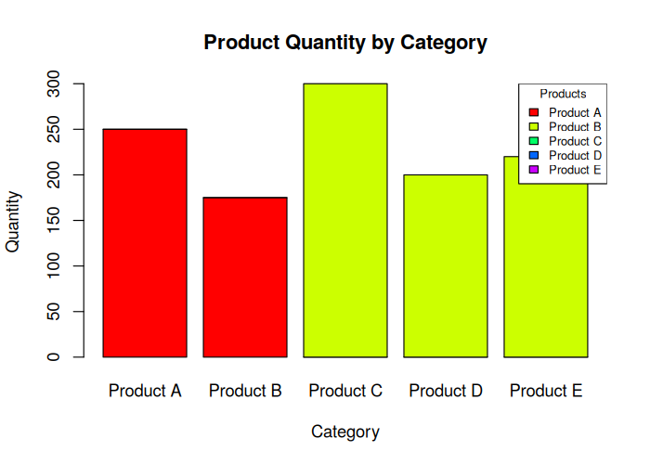
c) Tableau Dashboard: Bar Chart + Stacked Bar Chart
R code:
library(shiny)
ui <- fluidPage(
titlePanel("Product Inventory Dashboard"),
sidebarLayout(
sidebarPanel(selectInput("cat", "Category:", choices = c("All", unique(inventory$Category)))),
mainPanel(plotOutput("barPlot"), plotOutput("stackedPlot"))
)
)
server <- function(input, output) {
output$barPlot <- renderPlot({
barplot(inventory$Quantity, names.arg = inventory$ProductName,
col = "skyblue", xlab = "Product", ylab = "Quantity",
main = "Product Inventory")
})
output$stackedPlot <- renderPlot({
table_data <- xtabs(Quantity ~ Category + ProductName, data = inventory)
barplot(table_data, beside = FALSE, col = rainbow(ncol(table_data)),
main = "Quantity by Category", xlab = "Category", ylab = "Quantity")
legend("topright", legend = colnames(table_data), fill = rainbow(ncol(table_data)))
})
}
shinyApp(ui = ui, server = server)
output:
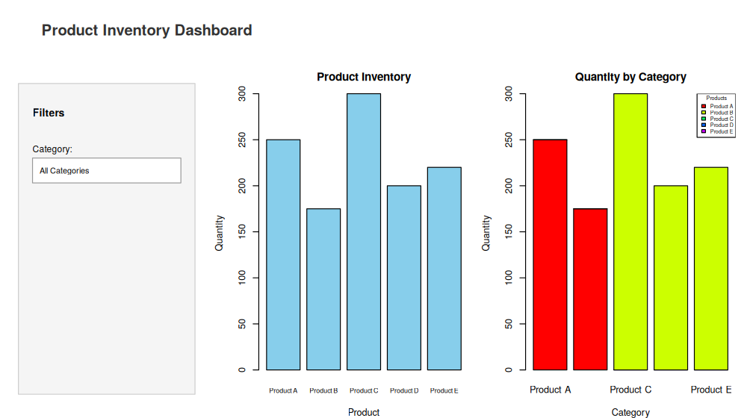
d) Scatter Plot: Product Price vs Quantity Available
R code:
plot(inventory$Price, inventory$Quantity,
pch = 19, col = "red",
xlab = "Product Price ($)", ylab = "Quantity Available",
main = "Price vs Quantity Available")
abline(lm(Quantity ~ Price, data = inventory), col = "blue", lwd = 2)
output:
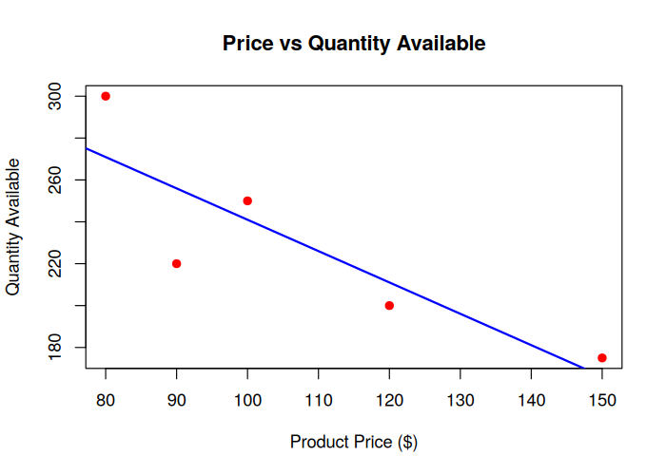

Set 25: Website Traffic Analysis
Dataset: Website Traffic
traffic <- data.frame(
Date = as.Date(c("2023-01-01","2023-01-02","2023-01-03",
"2023-01-04","2023-01-05")),
PageViews = c(1500,1600,1400,1650,1800),
CTR = c(2.3,2.7,2.0,2.4,2.6),
Likes = c(200,220,180,240,260),
Shares = c(80,90,70,85,95),
Comments = c(40,50,35,45,55)
)
a) Tableau: Line Chart for Trend in Page Views Over Time
R code:
plot(traffic$Date, traffic$PageViews, type = "o",
col = "blue", lwd = 2, pch = 16,
xlab = "Date", ylab = "Page Views",
main = "Daily Website Page Views")
output:
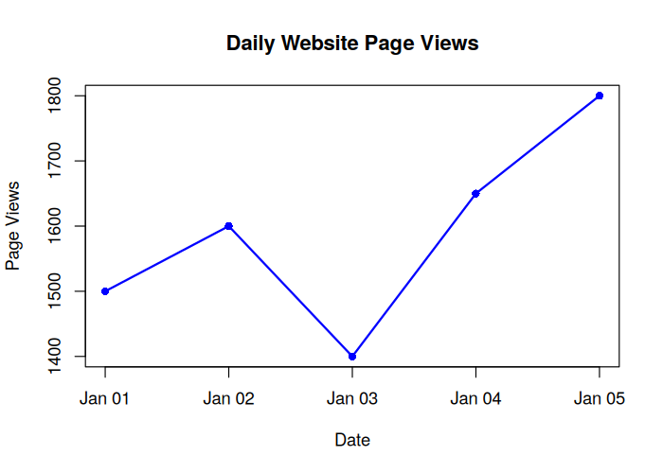
b) Bar Chart: Top Days by Click-through Rate
R code:
traffic_sorted <- traffic[order(-traffic$CTR), ]
barplot(traffic_sorted$CTR,
names.arg = format(traffic_sorted$Date, "%b %d"),
col = "orange",
xlab = "Date", ylab = "Click-through Rate (%)",
main = "Top Days by Click-through Rate")
output:
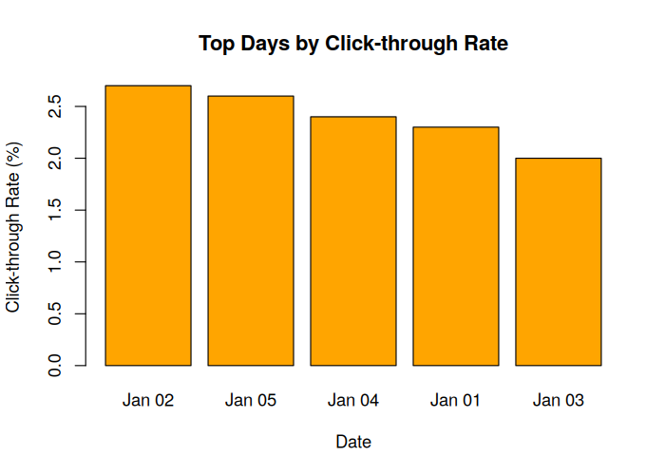
c) Stacked Area Chart: User Interactions (Likes, Shares, Comments)
R code:
x <- 1:nrow(traffic)
y1 <- traffic$Comments
y2 <- traffic$Comments + traffic$Shares
y3 <- traffic$Comments + traffic$Shares + traffic$Likes
plot(x, y3, type = "n", xaxt = "n", xlab = "Date", ylab = "Count",
main = "User Interactions Over Time (Stacked Area)")
axis(1, at = x, labels = format(traffic$Date, "%b %d"))
polygon(c(x, rev(x)), c(rep(0,length(x)), rev(y1)), col = "cornflowerblue", border = NA)
polygon(c(x, rev(x)), c(y1, rev(y2)), col = "seagreen3", border = NA)
polygon(c(x, rev(x)), c(y2, rev(y3)), col = "salmon", border = NA)
legend("topleft", legend = c("Comments","Shares","Likes"),
fill = c("cornflowerblue","seagreen3","salmon"), bty = "n")
output:
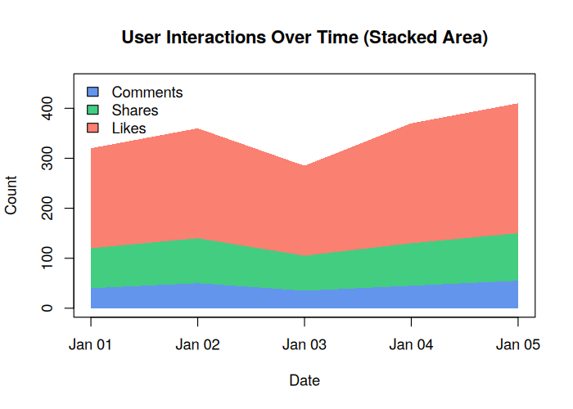
d) Tableau Dashboard: Interactive Map of Traffic Sources + Page Views by Source
R code:
library(shiny)
library(maps)
sources <- data.frame(
Source = c("Organic Search","Direct","Social Media","Referral","Email"),
City = c("New York","Chicago","Los Angeles","Houston","Miami"),
lon = c(-74.006, -87.629, -118.243, -95.369, -80.191),
lat = c(40.7128, 41.8781, 34.0522, 29.7604, 25.7617),
PageViews = c(3200, 2100, 1800, 950, 700)
)
ui <- fluidPage(
titlePanel("Website Traffic Sources Dashboard"),
sidebarLayout(
sidebarPanel(selectInput("src", "Traffic Source:", choices = c("All", sources$Source))),
mainPanel(plotOutput("mapPlot"), plotOutput("barPlot"))
)
)
server <- function(input, output) {
output$mapPlot <- renderPlot({
map("usa", col = "grey85", fill = TRUE, border = "white")
points(sources$lon, sources$lat, pch = 21, bg = rgb(0.2,0.4,0.8,0.7),
cex = sqrt(sources$PageViews)/12, col = "darkblue")
text(sources$lon, sources$lat, labels = sources$Source, pos = 3, cex = 0.6)
title("Traffic Sources by Location")
})
output$barPlot <- renderPlot({
barplot(rev(sources$PageViews), names.arg = rev(sources$Source), horiz = TRUE,
col = "steelblue", las = 1, xlab = "Page Views",
main = "Page Views by Source")
})
}
shinyApp(ui = ui, server = server)
output:
